TOGAF® Standard – Implementation and Migration Plan
Version 1.0
October 2026
Barangay San Antonio Health Department Enterprise Architecture
Barangay San Antonio Health Center, Pasig City
Document Version History
Version  Number | Version  Date | Revised By | Description | Filename
1.0 | October 22, 2026 | UA&P Solution Architecture team | First issue, based on interviews (October 2–21, 2026) and verification answers (October 22, 2026) | E4 - Implementation and Migration Plan.docx

Contents
1. Purpose of this Document 5
1.1 Output and Input 5
2. Implementation and Migration Strategy 6
2.1 Strategic Implementation Direction 6
2.2 Implementation Sequencing Approach 6
3. Project and Portfolio Breakdown of Implementation 7
3.1 Allocation of Work Packages to Project and Portfolio 7
3.2 Capabilities Delivered by Projects 7
3.3 Milestones and Timing 7
3.4 Work Breakdown Structure 7
3.5 May Include Impact on Existing Portfolio, Program, and Projects 8
4. Project Charters 9
4.1 Included Work Packages 9
4.2 Business Value 9
4.3 Risk, Issues, Assumptions, Dependencies 9
4.4 Resource Requirements and Costs 9
4.5 Benefits of Migration, Determined (Including Mapping to Business Requirements) 10
4.6 Estimated Costs of Migration Options 10
A Abbreviations 11
Tracking Information
Project Name | Barangay San Antonio Health Department Enterprise Architecture
Prepared By | Rome Victor Mag-iba Sendin (Group Leader); Samuel Anthonius Badillo; Wilson Halim; Kevin Enrico Ang | Document Version No. | 1.0
Title | Implementation and Migration Plan | Document Version Date | October 22, 2026
Reviewed By | Dr. Glynnis Lynn U. Bonilla, Medical Officer IV (Executive Sponsor) | Review Date | October 23, 2026
Distribution List
From | Date | Phone/Email
Rome Victor Mag-iba Sendin, Group Leader, UA&P Solution Architecture | October 22, 2026 | romevictor.sendin@uap.asia / 09456315746

To | Action* | Due Date | Phone//Email
Dr. Glynnis Lynn U. Bonilla, Medical Officer IV | Approve | October 23, 2026 | bsahealthcenter@gmail.com
Hon. Thomas Raymond U. Lising, Punong Barangay | Review | October 23, 2026 | bsahealthcenter@gmail.com
Hon. Rachel Marie S. Rustia-Olarte, Co-Chair, Committee on Health & Nutrition | Review | October 23, 2026 | bsahealthcenter@gmail.com
Mr. Joel Pira, Instructor, Solution Architecture (UA&P) | Review | October 23, 2026 | joel.pira@uap.asia
* Action Types: Approve, Review, Inform, File, Action Required, Attend Meeting, Other (please specify)

Purpose of this Document
The Implementation and Migration Plan provides a schedule of the projects that will realize the Target Architecture. The Implementation and Migration Plan includes executable projects grouped into managed portfolios and programs. The Implementation and Migration Strategy identifying the approach to change is a key element of the Implementation and Migration Plan.

Output and Input
The TOGAF® Content Framework (see Architecture Deliverables) identifies deliverables that are produced as outputs from executing the Architecture development Method (ADM) cycle and potentially consumed as inputs at other points in the ADM.
This deliverable is produced, updated, and consumed by the ADM Phases:
Deliverable | Output from… | Input to…
Implementation and Migration Plan | E, F | F

Implementation and Migration Strategy

Strategic Implementation Direction
Start with what the barangay and health center control and can fund quickly, use free or low-cost tools, keep the City EMR as the system of record, and build an evidence-based case for City-level changes in parallel.

Implementation Sequencing Approach
- Quick wins first (November–December 2026), timed to the barangay budget deadline (November 2026).
- No rollouts during OPT Plus and MR-SIA (January–March) or month-end reporting.
- Equipment and digitization in April–June 2027, after the field season.
- Integration and extension in July–December 2027, depending on City responses.
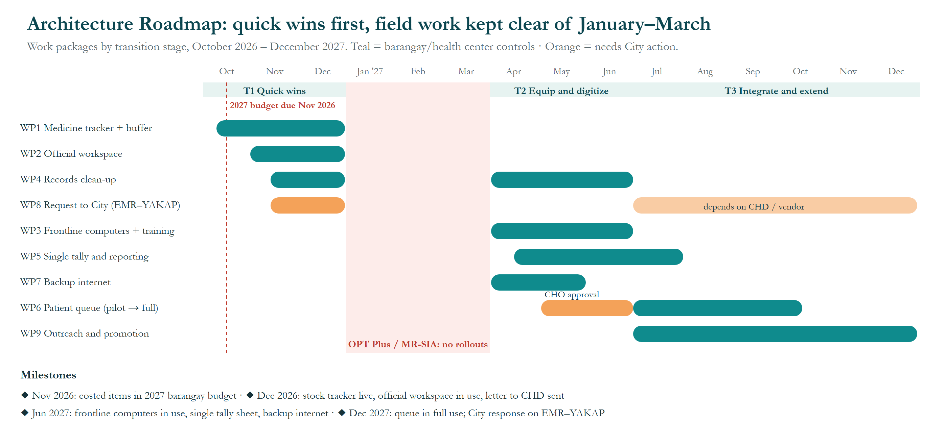
Figure 1. Architecture Roadmap.
What this shows: when each improvement (work packages WP1–WP9) happens between October 2026 and December 2027. Teal bars are things the barangay or health center controls; orange bars need City action. Nothing new is rolled out from January to March, when staff are busy with OPT Plus and MR-SIA field work. Why it matters: quick, low-cost wins come first, timed to the 2027 barangay budget due in November 2026.

Project and Portfolio Breakdown of Implementation

Allocation of Work Packages to Project and Portfolio
Project | Work packages | Sponsor
P1 Medicine Assurance | WP1 | Kagawad Rustia; Nurse Hardman
P2 Digital Workplace | WP2, WP3, WP5, WP7 | Kapitan Lising
P3 Records Modernization | WP4 | Dr. Bonilla
P4 Patient Flow | WP6 | Dr. Bonilla; UA&P IT program
P5 City Interoperability | WP8 | Dr. Bonilla; Kapitan Lising
P6 Community Reach | WP9 | Kagawad Rustia

Capabilities Delivered by Projects
Project | Capability improved (baseline → target)
P1 | Medicine and supply logistics 2 → 4
P2 | IT and equipment 2 → 4; Reporting and compliance 3 → 4
P3 | Records management 2 → 4
P4 | Patient care 3 → 4
P5 | Records management and patient care (City-wide)
P6 | Community outreach 3 → 4

Milestones and Timing
Date | Milestone
November 2026 | Costed items (WP1 buffer, WP3, WP7, WP9) proposed in the 2027 barangay budget
December 2026 | Stock tracker live (WP1); official workspace in use (WP2); active-chart index started (WP4); letter to the City Health Department sent (WP8)
January–March 2027 | No rollouts (OPT Plus and MR-SIA field work)
June 2027 | Frontline computers in use (WP3); single tally sheet (WP5); backup internet (WP7); queue pilot running after CHO approval (WP6)
December 2027 | Queue in full use (WP6); outreach expanded (WP9); City response on EMR–YAKAP integration (WP8)

Work Breakdown Structure
Project | Main tasks
P1 | Design stock sheet with reorder levels → load current balances → train nurse and aides → reconcile monthly → propose buffer line
P2 | Set up barangay account and shared drive → migrate program files → work-only chat groups → buy and install computers → train aides and BHWs → build tally sheet → install backup line
P3 | Agree filing standard → build active-chart index → box and label inactive charts → schedule disposal → install cabinet and key log
P4 | Seek CHO approval → define queue rules → UA&P capstone build → pilot on consultation days → review
P5 | Compile evidence (retyping time, examples) → letter via Nurse Hardman → follow up quarterly
P6 | Plan Wellness Pop-up calendar with condo admins → oral health campaign → equip BNS for field entry

May Include Impact on Existing Portfolio, Program, and Projects
No conflict with City programs. P4 aligns with Dr. Bonilla's goal of a queuing system and the UA&P IT capstone pipeline. P6 builds on the existing Community Wellness Pop-ups.

Project Charters

Included Work Packages
Project | Work package | Description
P1 | WP1 Medicine stock tracker and buffer stock | Shared stock sheet (beginning balance, received, issued, ending balance, reorder level) updated daily; standing barangay buffer line for maintenance medicines (Metformin, Losartan, Amlodipine ran short in 2026)
P2 | WP2 Official workspace and communication | Barangay-owned Google account or Workspace with a shared drive for program files; work-only chat groups; storage for OPT files
P2 | WP3 Frontline computers and digital skills | 2–3 shared desktops for the 4 Pasig Health Aides and 3 BHWs; basic computer workshops (UA&P outreach)
P3 | WP4 Records clean-up and security | Active-chart index by record number for the ~8,000 charts; archive inactive charts on the DOH 7-year schedule; lockable records cabinet and key log; request consent once per patient (CHD approval)
P2 | WP5 Single tally and reporting | Aides and BHWs enter daily tallies once on the shared computer; program reports built from that sheet; request CHD to accept digitally signed reports
P4 | WP6 Patient queue | Numbered tickets and display for consultation days; built as a UA&P IT capstone pilot after City Health Officer approval
P2 | WP7 Backup connectivity | Second provider or LTE router with failover alongside the PLDT line; written outage procedure (paper fallback)
P5 | WP8 City interoperability request | Evidence-based letter to CHD: EMR–PhilHealth YAKAP prescription link, dental eMED link, replacement of 10-year-old City laptops, digital report submission
P6 | WP9 Outreach and health promotion | Condo partnerships through the Community Wellness Pop-ups; oral health campaigns; BNS field laptop and complete weighing kit

Business Value
No medicine stock-outs, less retyping, faster records, protected work data, fairer waiting and wider reach (details in the Architecture Roadmap, Business Value).

Risk, Issues, Assumptions, Dependencies
See the Architecture Roadmap, Implementation Factor Catalog. The key dependency is inclusion of costed items in the 2027 barangay budget (proposals due November 2026).

Resource Requirements and Costs
Work package | Resources | Indicative cost
WP1 Medicine stock tracker and buffer stock | Nurse Hardman; Kagawad Rustia | Tracker ₱0; buffer about ₱150,000–200,000 a year (2026 spend: about ₱150,000)
WP2 Official workspace and communication | Barangay IT; Kagawad Rustia | ₱0 (shared barangay account) to about ₱4,000–5,000 a month (paid workspace, about 10 users)
WP3 Frontline computers and digital skills | Kapitan Lising; UA&P team | About ₱50,000–105,000 for 2–3 desktops; training ₱0
WP4 Records clean-up and security | Ms. Roa (custodian); Ms. Abong | Cabinet about ₱10,000–20,000; staff time
WP5 Single tally and reporting | Ms. Abong; Nurse Hardman | ₱0 (templates)
WP6 Patient queue | Dr. Bonilla; UA&P IT program | Development ₱0 (capstone); ticket printer and display about ₱15,000–30,000
WP7 Backup connectivity | Barangay IT | About ₱1,500–2,500 a month plus router
WP8 City interoperability request | Dr. Bonilla; Kapitan Lising | ₱0 to the barangay
WP9 Outreach and health promotion | Kagawad Rustia; Dr. Magpali; Mr. Vasquez | Field laptop about ₱30,000; weighing kit to be quoted

Costs are indicative estimates from typical 2026 Philippine retail prices, not quotations; they must be verified through barangay procurement.
Indicative total: one-time about ₱105,000–185,000 (computers, cabinet, queue hardware, field laptop) plus about ₱150,000–200,000 a year for the medicine buffer and about ₱18,000–90,000 a year for connectivity and workspace, depending on options chosen.

Benefits of Migration, Determined (Including Mapping to Business Requirements)
Benefit | Requirement | Measure
Medicines on hand | R-02, R-03 | SM-2: stock-out months → 0
One prescription entry (if City adopts) | R-01 | SM-1: 3 → 1
Faster records | R-09, R-10 | SM-3: < 1 minute
Reports in working hours | R-07 | SM-4: none after hours
Protected work data | R-05 | SM-6: none on personal accounts
Frontline staff equipped | R-04, R-11 | SM-7: all with access
Fairer queue | R-06 | Fewer complaints
Consultations through outages | R-08 | No paper-only days

Estimated Costs of Migration Options
Decision | Option A (lowest cost) | Option B (stronger)
Workspace | Free shared barangay Google account and drive | Paid Google Workspace (~₱4,000–5,000 a month, ~10 users)
Backup internet | Prepaid LTE router (~₱1,500 a month) | Second fiber provider (~₱2,500 a month)
Frontline computers | 2 desktops (~₱50,000–70,000) | 3 desktops (~₱75,000–105,000)
Queue | Paper numbered tickets + whiteboard (~₱0) | UA&P capstone app with display (~₱15,000–30,000 hardware)

Costs are indicative estimates from typical 2026 Philippine retail prices, not quotations; they must be verified through barangay procurement.

- Abbreviations
Abbreviations, acronyms and reference codes used in this document and its figures, in alphabetical order.
Abbreviation | Meaning
ADM | Architecture Development Method, the step-by-step method of the TOGAF Standard
BHW | Barangay Health Worker
BNS | Barangay Nutrition Scholar
CHD | City Health Department (Pasig City)
CHO | City Health Officer
DOH | Department of Health
eMed / eMED | Name of the City's electronic medical record system; “dental eMED” is its separate dental system
EMR | Electronic Medical Record
Hon. | Honorable (title of elected officials)
IT | Information technology
LTE | Long-Term Evolution (4G mobile internet)
MR-SIA | Measles-Rubella Supplemental Immunization Activity
OPT / OPT Plus | Operation Timbang Plus: yearly weighing and measuring of children aged 0–59 months
PhilHealth | Philippine Health Insurance Corporation
PLDT | PLDT Inc., an internet and telephone provider
R-01 … | Stakeholder requirement reference number
SM-1 … | Success measure reference number
T1 … T3 | Transition architecture stage
TOGAF | The Open Group Architecture Framework (the TOGAF® Standard)
UA&P | University of Asia and the Pacific
WP1 … WP9 | Work package (a group of related changes delivered together)
YAKAP | PhilHealth Yaman ng Kalusugan Program (primary-care benefit)

